**Prime factors of a number**

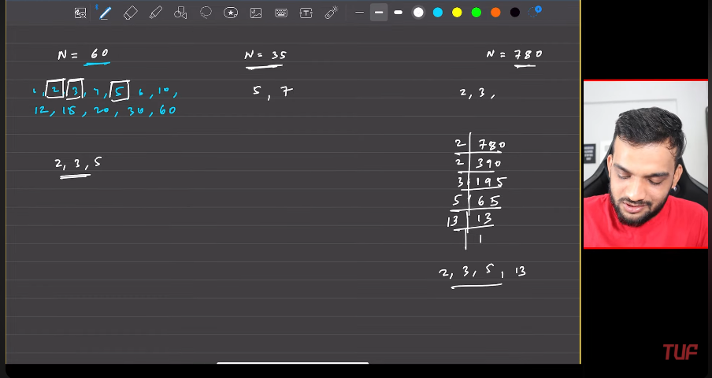

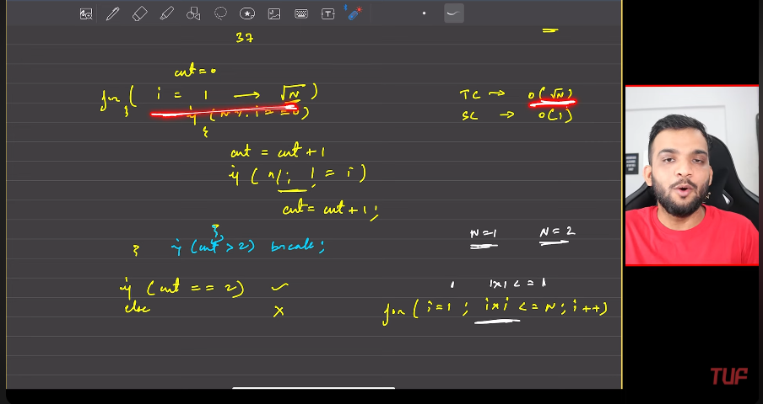

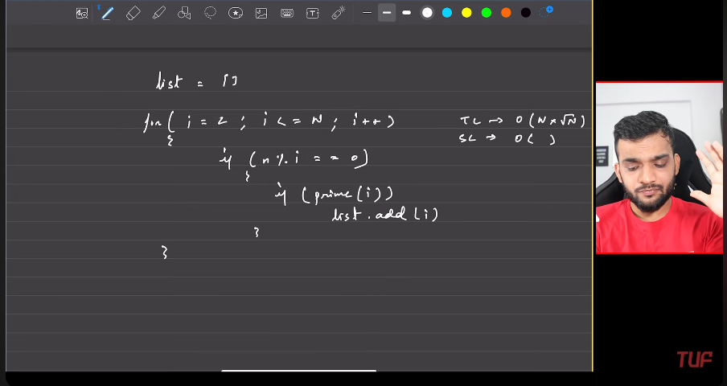

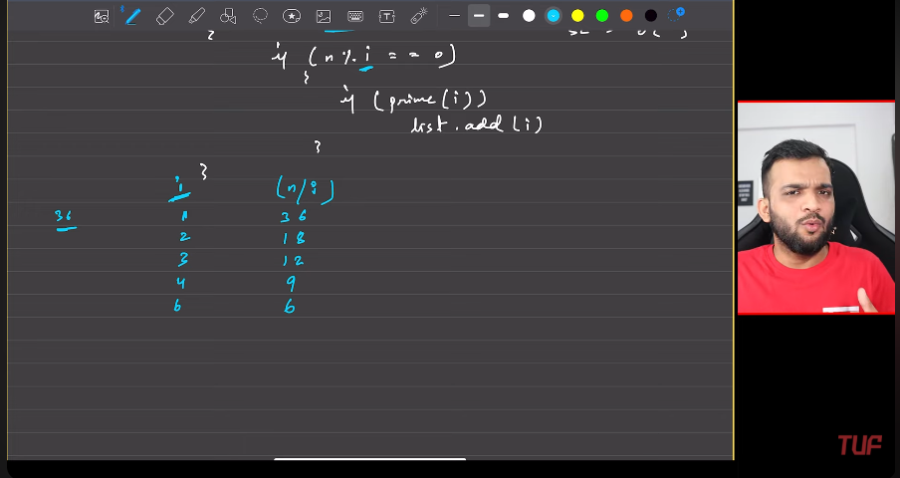

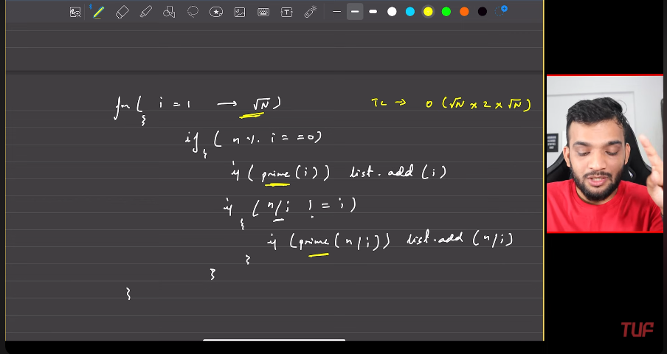

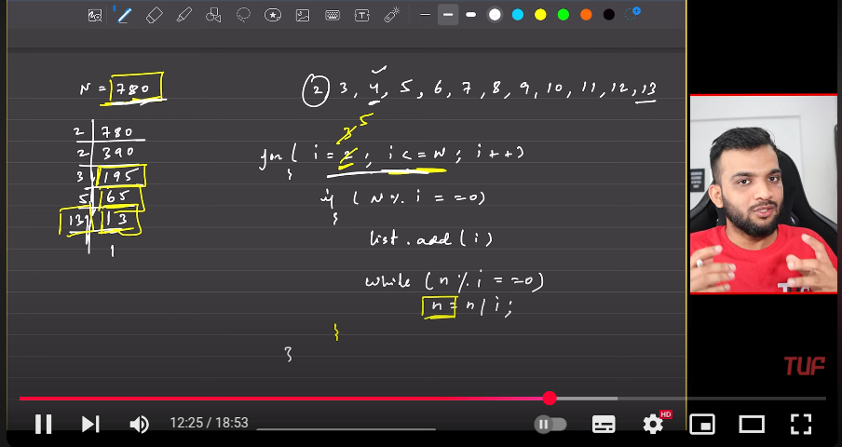

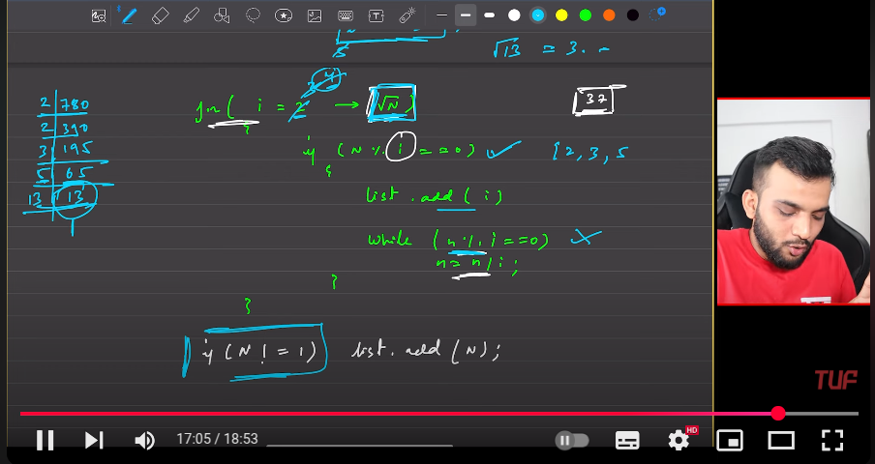

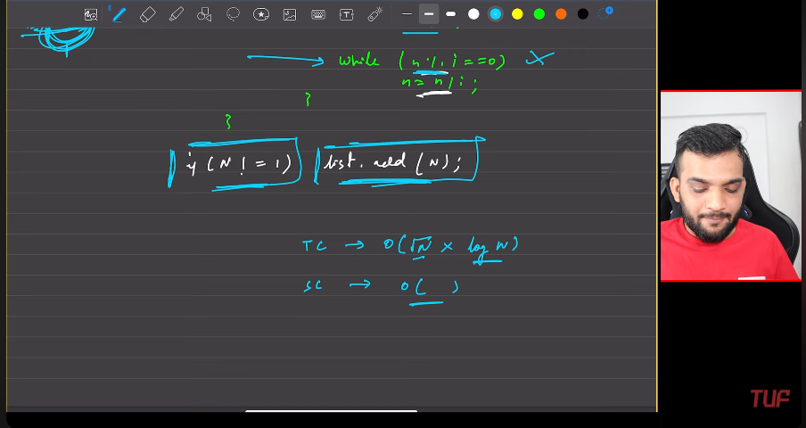

**Print all the divisors of a number**

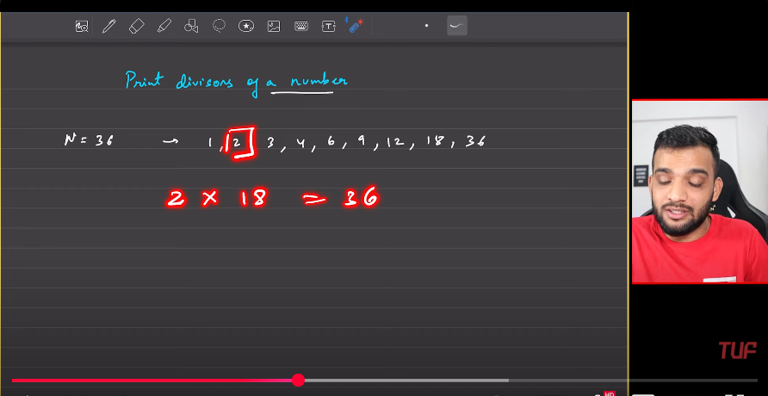

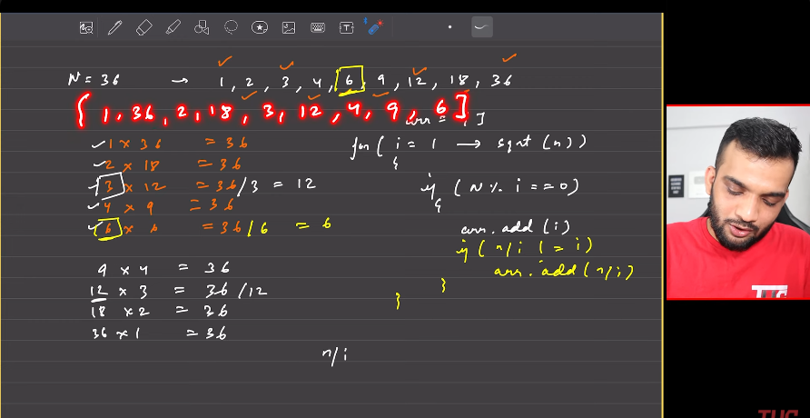

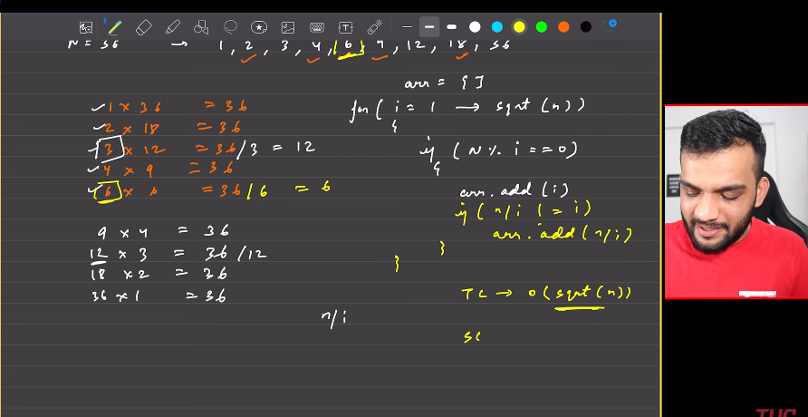

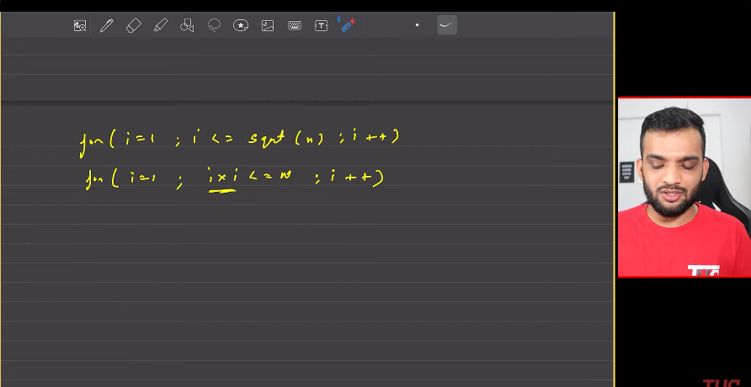

**Sieve of eratosthenes**

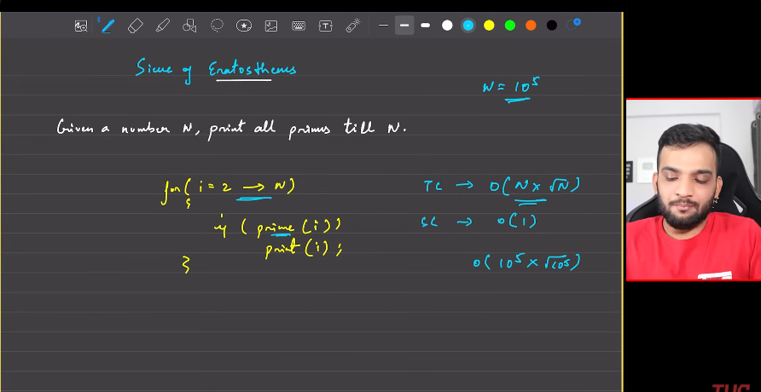

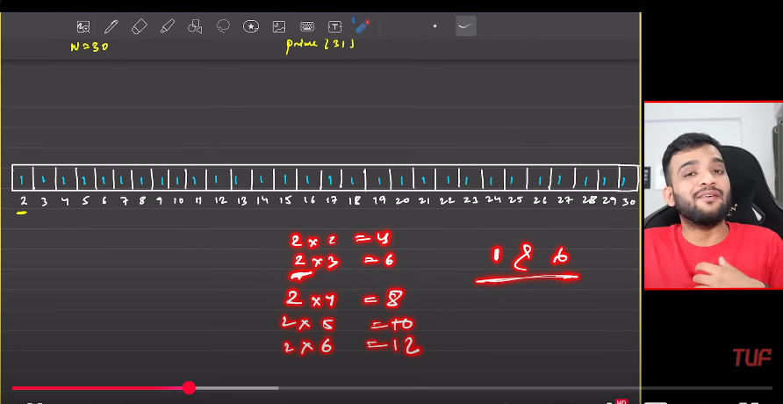

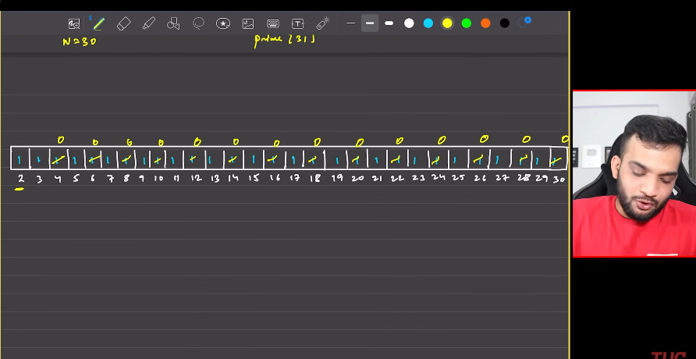

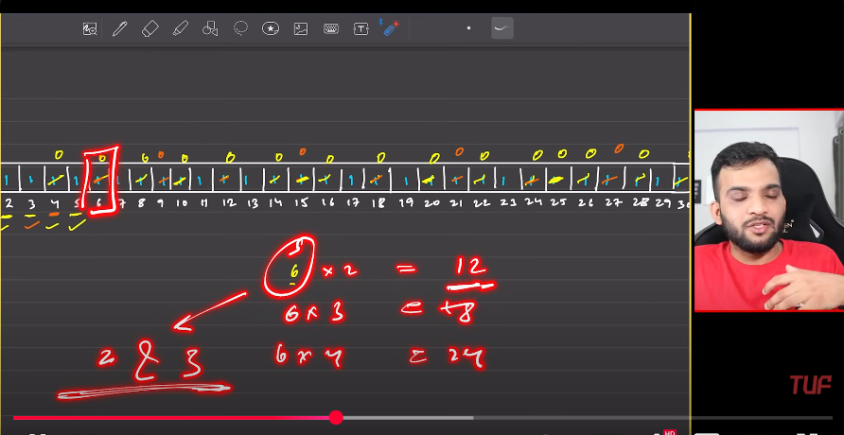

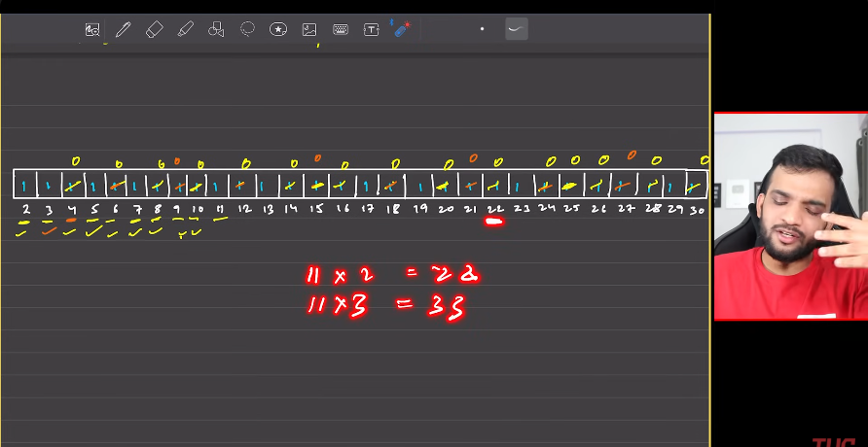

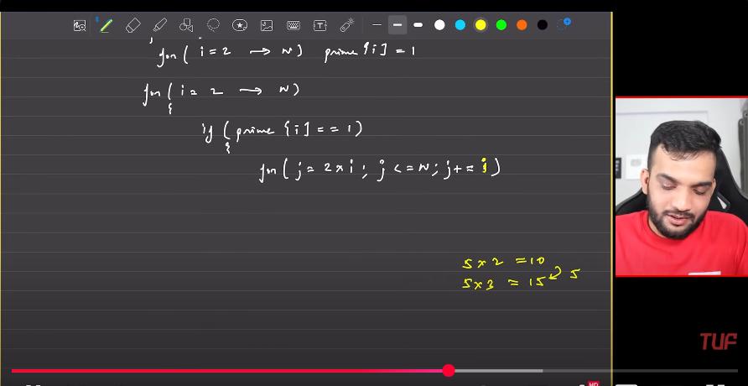

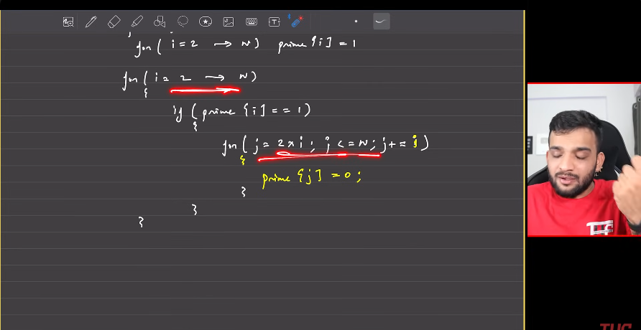

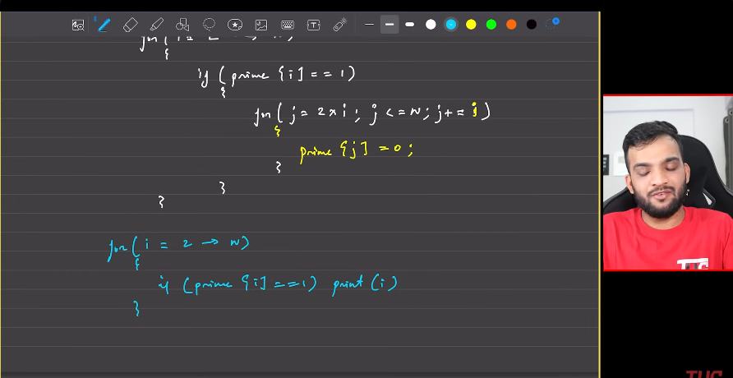

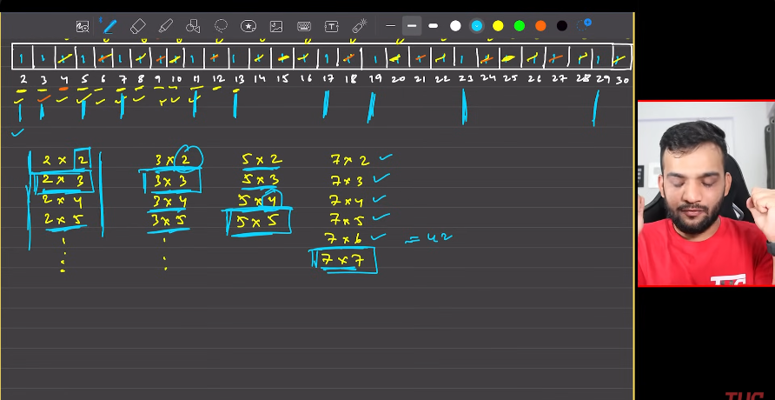

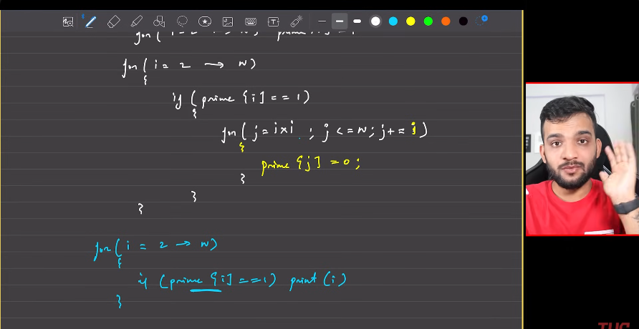

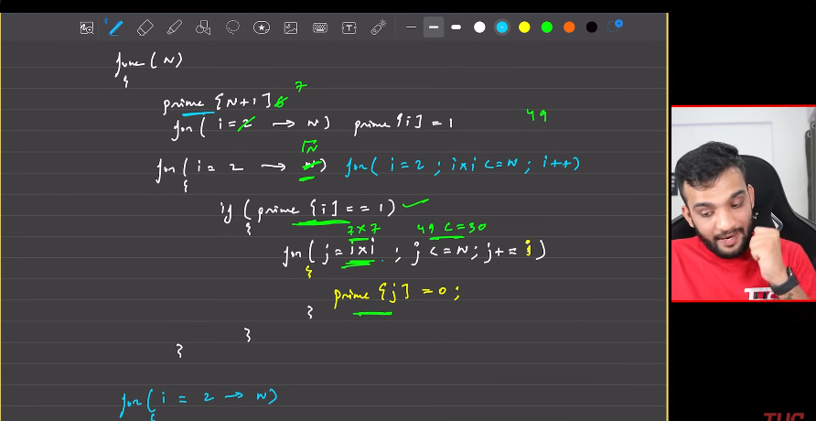

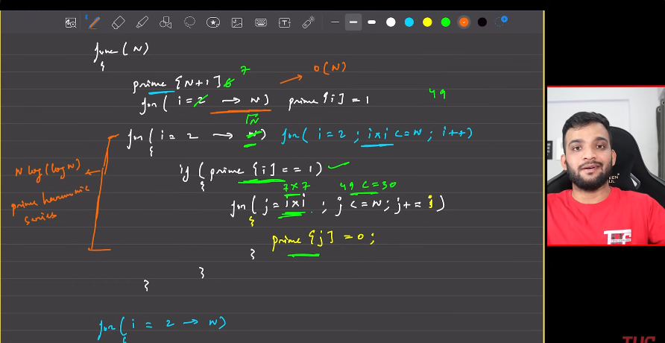

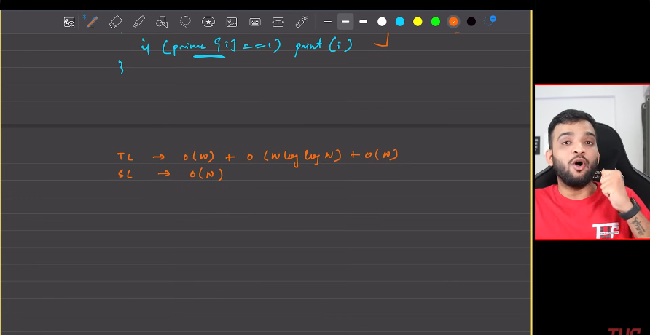

Finding the prime factors a number using seive:

1. Get a string of length equal to n+1, make all the elements to be equal to 1.
2. Then start iterating with 2 till n.
   1. The multipliers of 2, are all should be 0, after 2, make in 2nd for loop.
   2. Similiarly traveser the whole arrray, of the array of that position is 1, then make the elment in the array to be zero, if it is multiple of the others .
   3. Need to start making the zero from i*i.
3. Finally the array is changed, then finnaly traverse the array from begging, the one which are having the entry 1, are the prime factors of the array.

**Finding the prime factorisation a number using sieve-2**

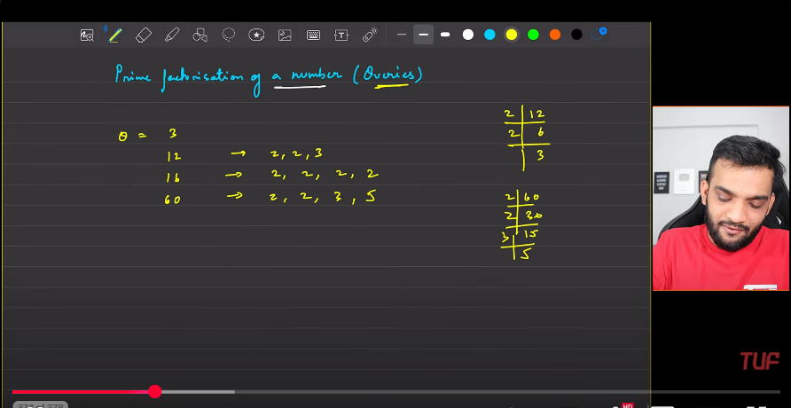

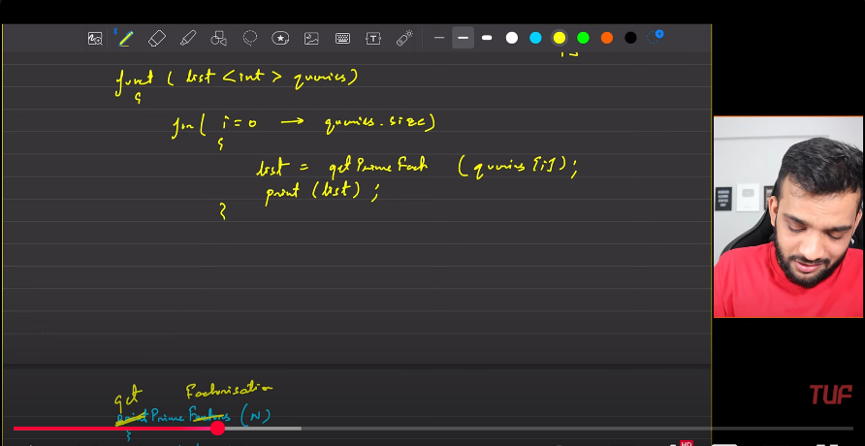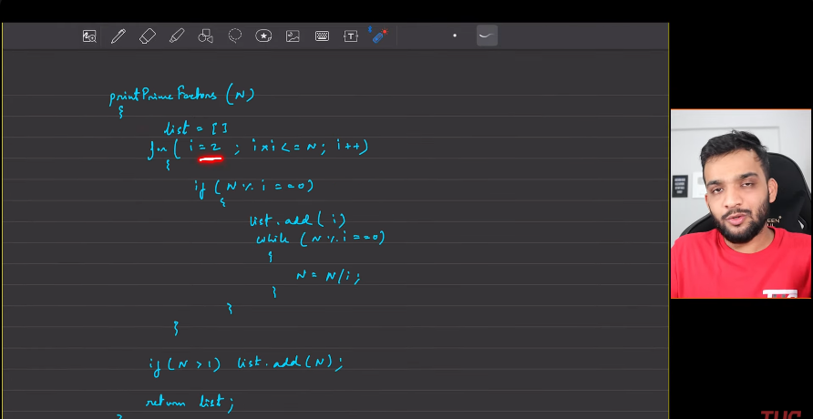

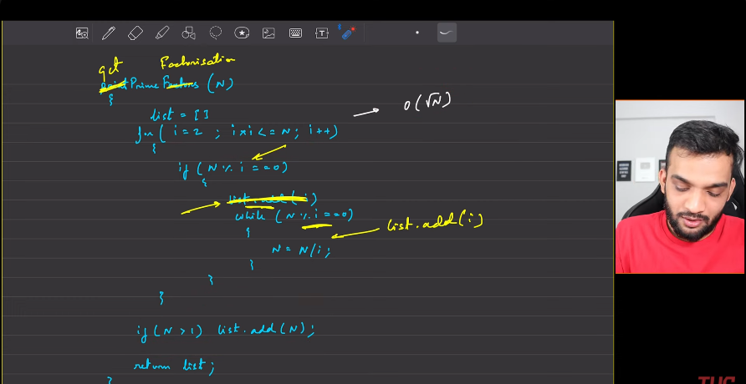

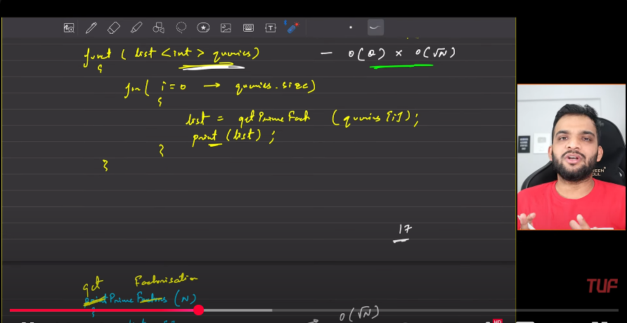

The above returns the unique elements.

**Need to optimize the square root of n.**

With the help smallest prime factor precomputed array.

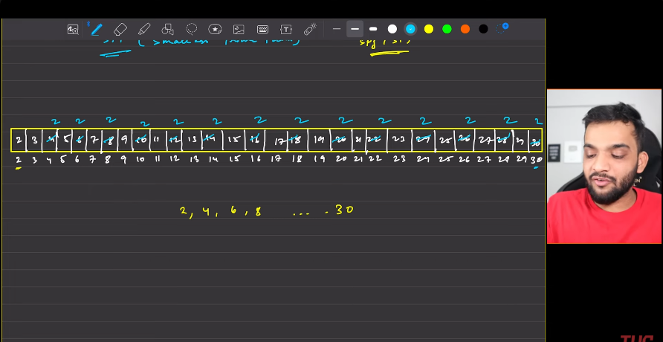

Above is turn 2.

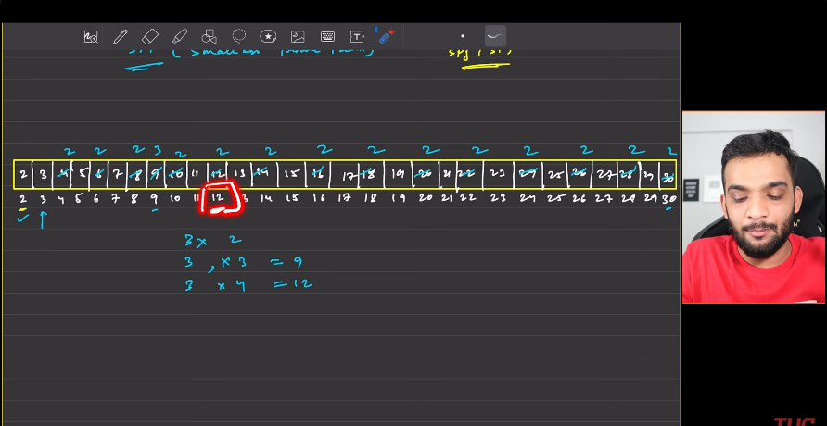

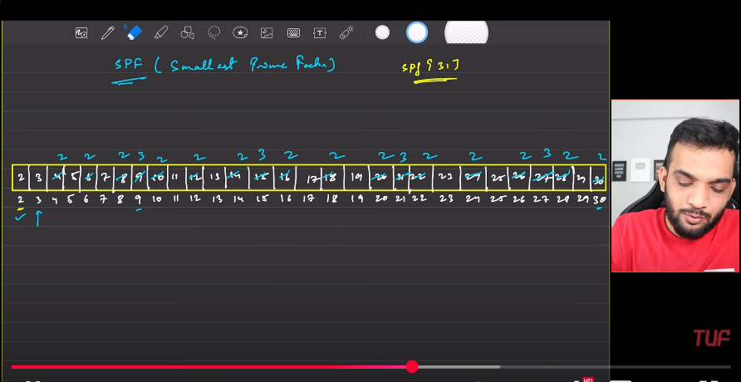

Above, turn 3

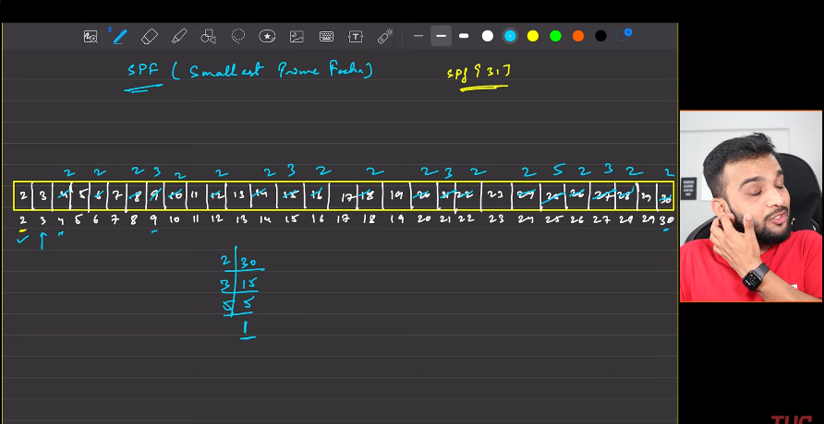

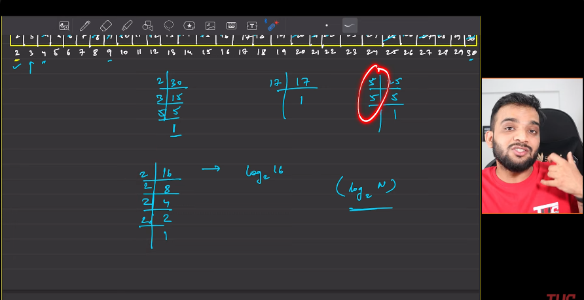

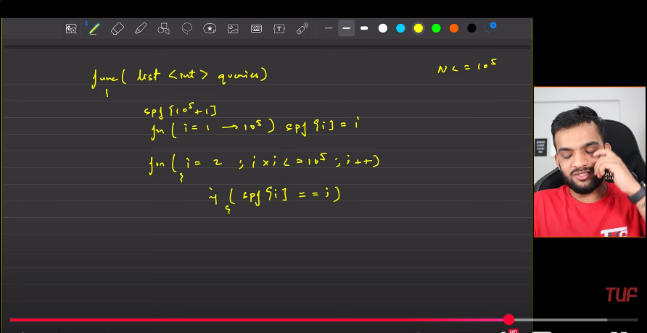

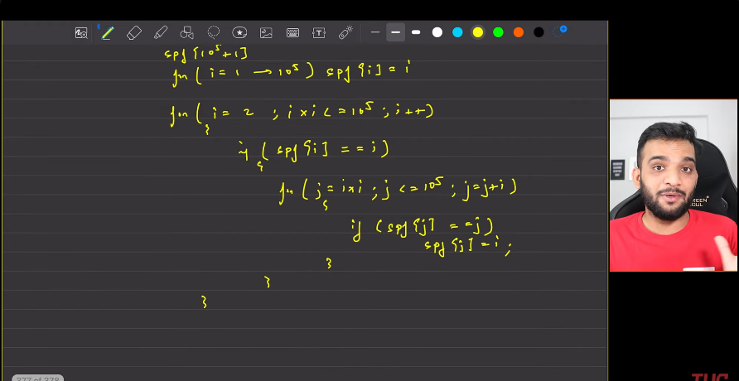

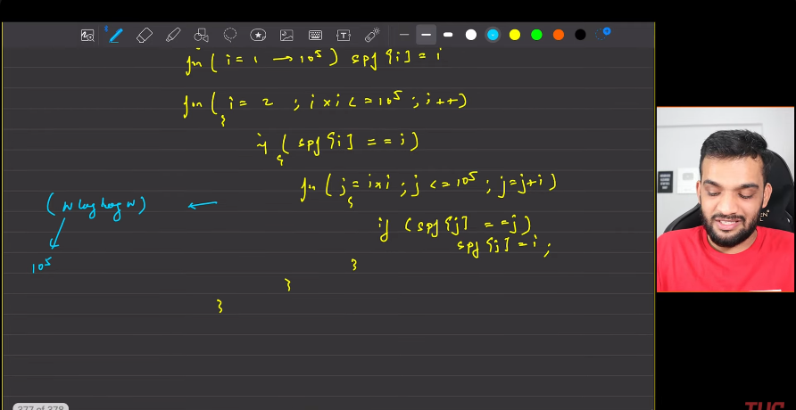

**Simple words**:

1. The precomputations to be calculated at first. ARR[i] = i.
2. Then start traversing from i=2, till n, for j=i*i, till it reaches the n, if the j is /i, then mark ARR[i] = j. Then keep moving.
3. Given the query, ARR[QUERY] => value, query = query/value, keep looping till the query becomes equal to 1. query=1.

**POWER EXPONENTIATION**:

1. 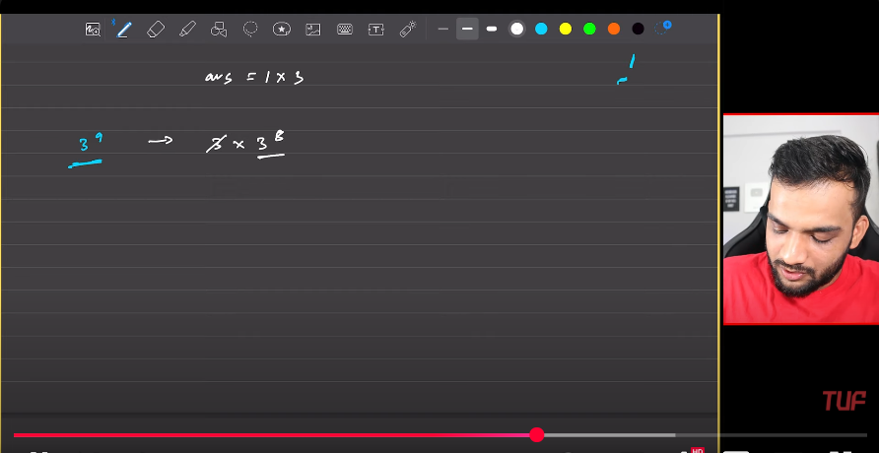
2. 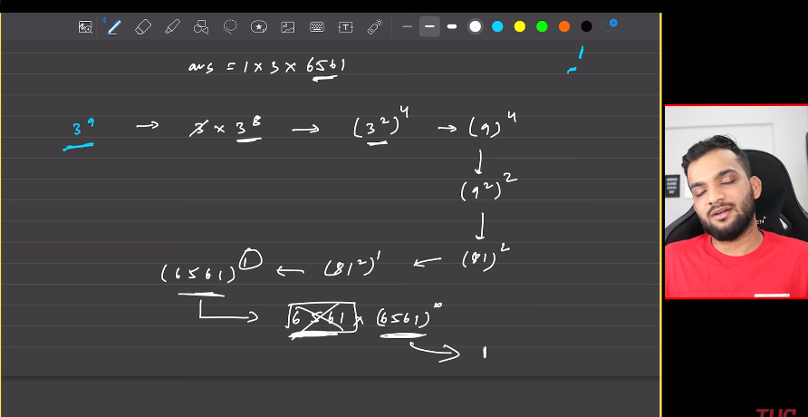
3. 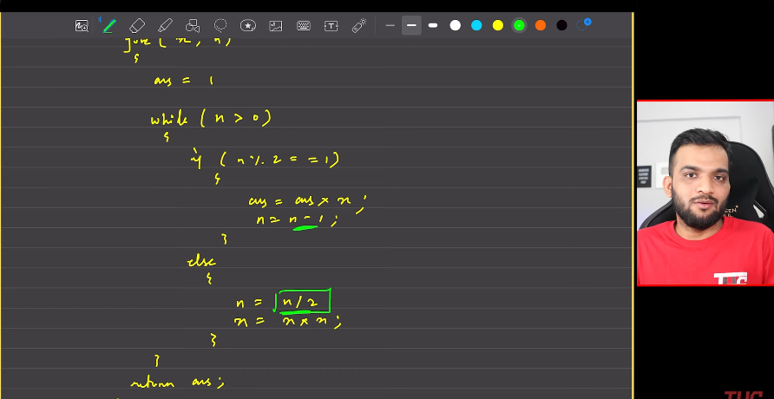
4. 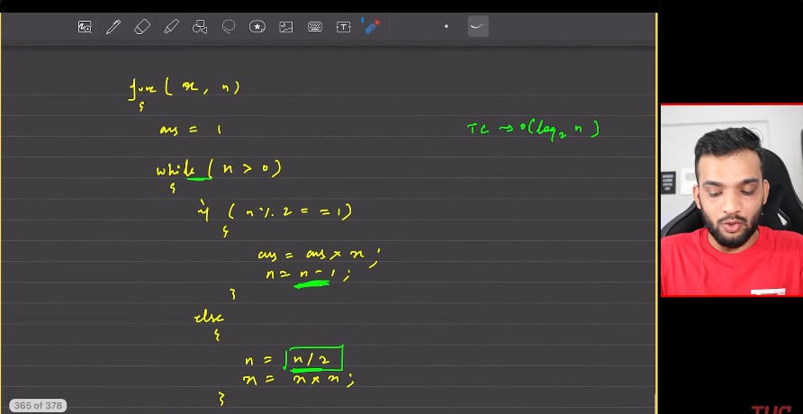
5. 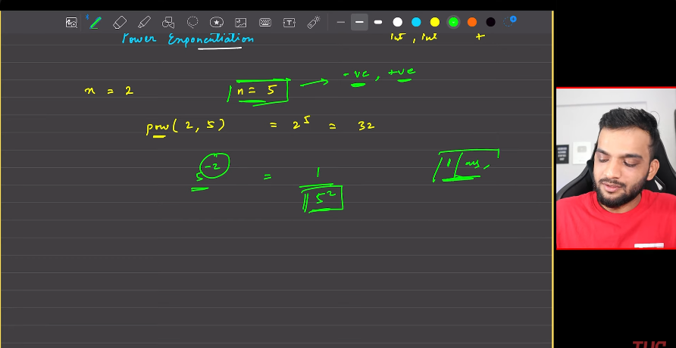
6. 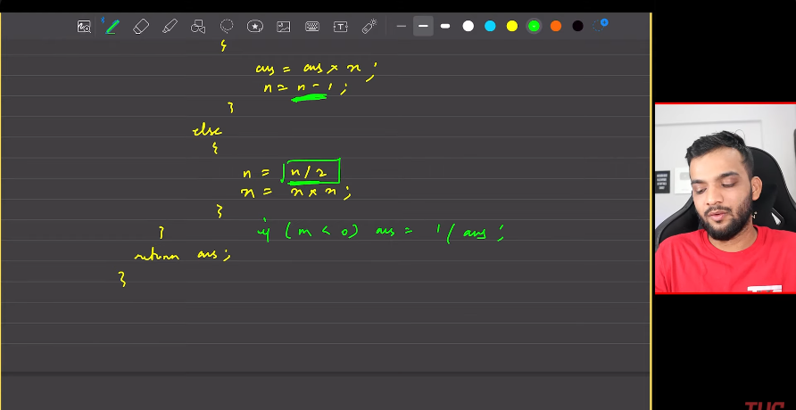
7. 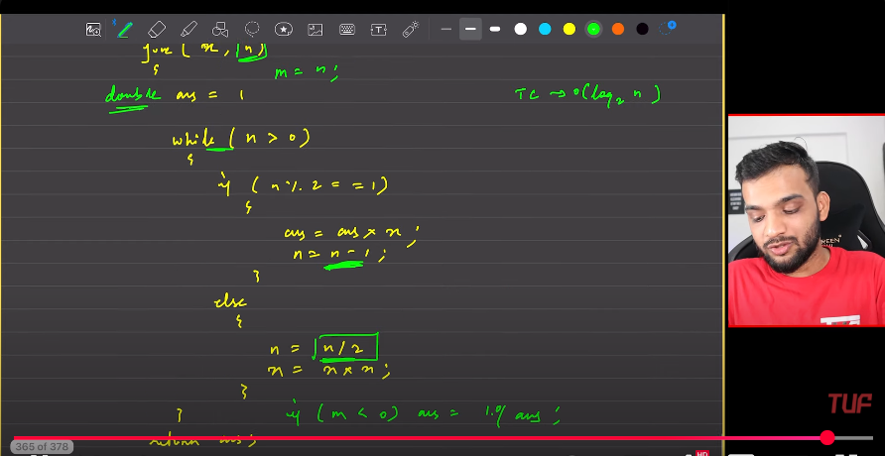
8. 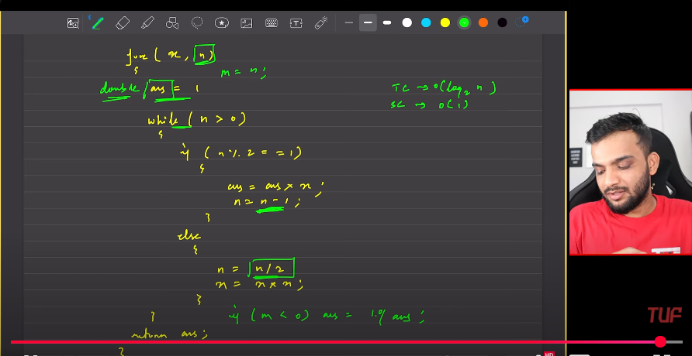
9. **My words**:
   1. We need 3 variables.
      1. One keeps track of the answer.
      2. Another one keeps track of the power series.
      3. power.
   2. When the power is odd, then we need to convert to even to make the power exponentiation. So in those situations whatever there is with x, I’ll multiply with ans. Hence the power will be reduced by one.
   3. When power is even, we divide the power/2. by multiplying the current base in powers of 2. x=x*x. power = power/2.

**Longest substring without repeating characters**.

1. 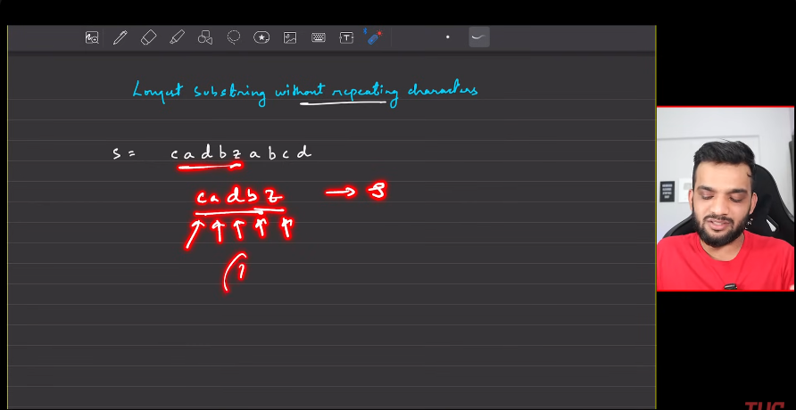
2. Extreme naive:
   1. Generate all the substring with the starting character.
   2. 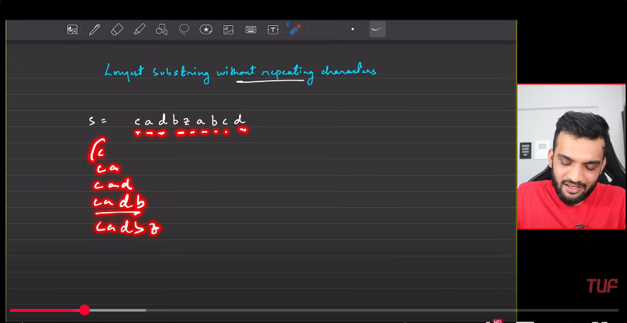
   3. 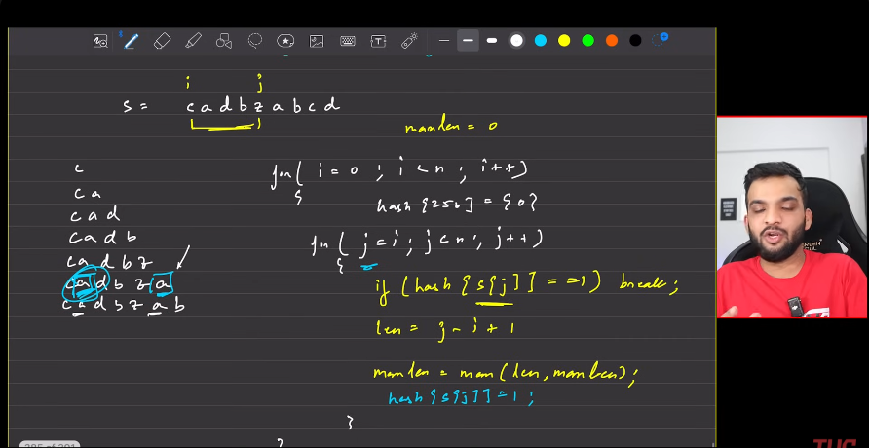
   4. Use hashmap to remember the elements of the array/string that has bee thorough.
   5. Finnaly print the maximum length, above os pretty much understandable.
   6. 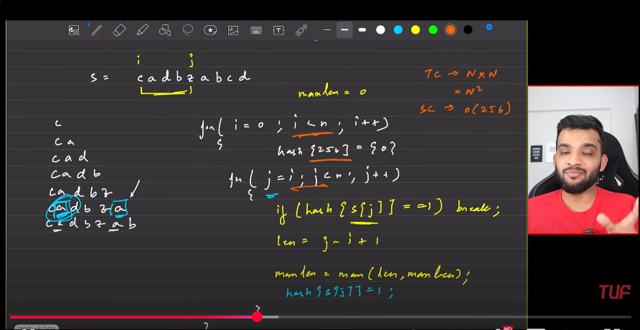
3. **Important**:
   1. Anything with the words substring maximum
4. s

**Integer to Binary**

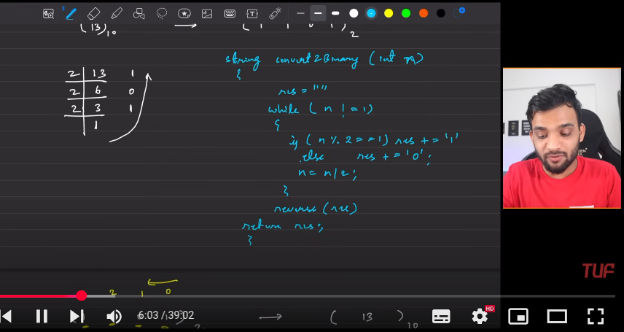

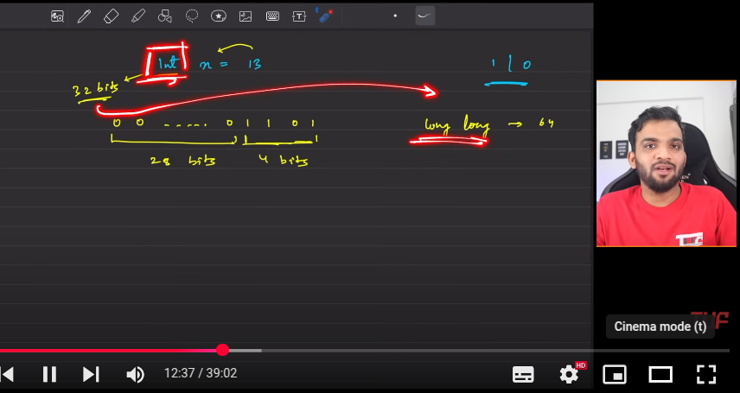

**Print Divisors of a number**

